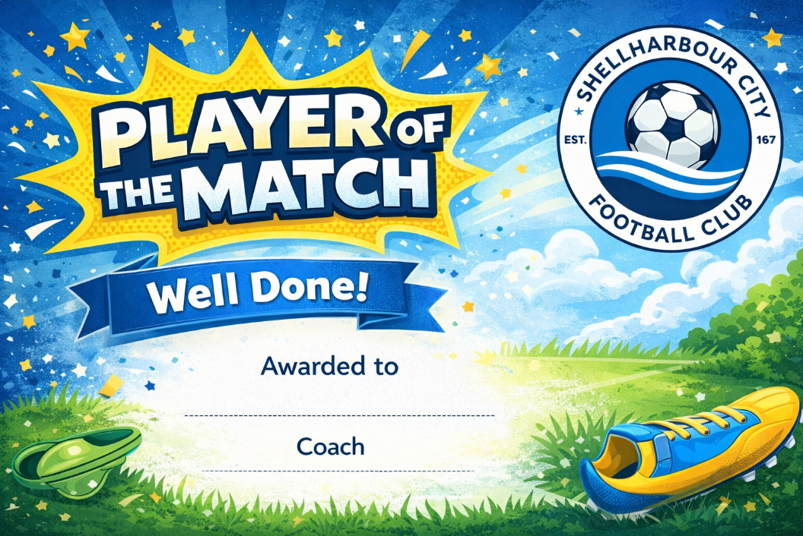
Your Name Here
Your Name Here
Your Name Here
Your Name Here

